Online School Portal
https://students.ashworthcollege.edu/dashboard
Username: Carriegilles@ymail.com
Password: 133Pinson

Sign in
Click on World Geography: Part 2
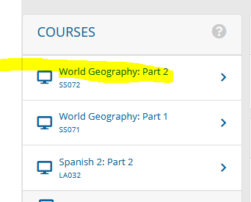

Click on Assessments
- Assignments
- Quizzes

